实验-------GDI与Windows绘图

学生姓名：张哲超 专业班级：计算机192
课程名称：Windows程序设计 实验类型：综合

一 实验目的
熟悉Windows编程的基本结构和框架，实现一个基本的Windows窗口程序。在此基础上，练习GDI（图形设备接口）编程。重点掌握Windows操作系统中的GDI环境获取、句柄、画笔、画刷、RGB颜色、常用的绘图函数等编程技术和应用。

二 实验环境
PC机 + Windows 操作系统 + Visual C++

三 实验内容
实验题目1
当点击鼠标左键时，在屏幕正中显示“你在（x,y）坐标点击了鼠标左键”；
当点击鼠标右键时，在屏幕正中显示“你在（x,y）坐标点击了鼠标右键”；
当双击鼠标左键时，在屏幕正中显示“你在（x,y）坐标双击了鼠标左键”。
x和y的值随鼠标移动实时变化。

实验过程1（思路（文字描述）、关键代码（WndProc 函数））
LRESULT CALLBACK WndProc(HWND hWnd,UINT message,WPARAM wParam,LPARAM lParam)
{
HDC hDC; //定义设备环境句柄.
HBRUSH hBr;
HPEN hPen;
PAINTSTRUCT ps; //定义包含绘图信息的结构体变量
static int i=0;
static int flag=0;

static WORD x, y;
char str_x[20], str_y[20];
char lpsz_1[50]="你在{ ";
char lpsz_2[]=" }坐标点击了鼠标左键";
char lpsz_3[]=" }坐标点击了鼠标右键";
char lpsz_4[]=" }坐标双击了鼠标左键";
static char pos[20] = "";
static int left_flag=0;
static int right_flag=0;
static int left_db_flag=0;
RECT rect;
GetClientRect(hWnd , &rect) ;
static int X, Y;
x=LOWORD(lParam);
y=HIWORD(lParam);
switch(message)
{
case WM_CREATE:
X=(rect.left+rect.right)/2;
Y=(rect.top+rect.bottom)/2;
break;

case WM_MOUSEMOVE:
sprintf(pos, "%d,%d", x, y);
InvalidateRect(hWnd,NULL,1);
break;

case WM_LBUTTONDOWN:
DWORD st;
DWORD et;
MSG msg;
st = GetTickCount();
while(1)
{
if(PeekMessage(&msg,NULL,0,0,PM_REMOVE))
{
TranslateMessage(&msg);
DispatchMessage(&msg);}
if(WM_LBUTTONDBLCLK == msg.message)
{
return DefWindowProc(hWnd,message,wParam,lParam);
}
et = GetTickCount();
if(et - st > 200)
break;
}

right_flag=0;
left_db_flag=0;
left_flag = 1;
InvalidateRect(hWnd,NULL,1);
break;

case WM_RBUTTONDOWN:
left_flag=0;
left_db_flag=0;
right_flag = 1;
InvalidateRect(hWnd,NULL,1);
break;

case WM_LBUTTONDBLCLK:
left_flag=0;
right_flag=0;
left_db_flag = 1;
InvalidateRect(hWnd,NULL,1);
break;

// case WM_LBUTTONUP:
// InvalidateRect(hWnd,NULL,1);

case WM_PAINT: //处理绘图消息.
hDC = BeginPaint(hWnd,&ps);
if(left_db_flag == 1){
strcat(pos,lpsz_4);
strcat(lpsz_1, pos);
TextOut(hDC,X,Y,lpsz_1,strlen(lpsz_1));

}
else if(left_flag == 1){
strcat(pos,lpsz_2);
strcat(lpsz_1, pos);
TextOut(hDC,X,Y,lpsz_1,strlen(lpsz_1));

}
else if(right_flag == 1){
strcat(pos,lpsz_3);
strcat(lpsz_1, pos);
TextOut(hDC,X,Y,lpsz_1,strlen(lpsz_1));

}

EndPaint(hWnd,&ps);
break;

case WM_DESTROY:
PostQuitMessage(0);
return 0;
default:
return DefWindowProc(hWnd,message,wParam,lParam);
}
return 0;
}
实验结果1
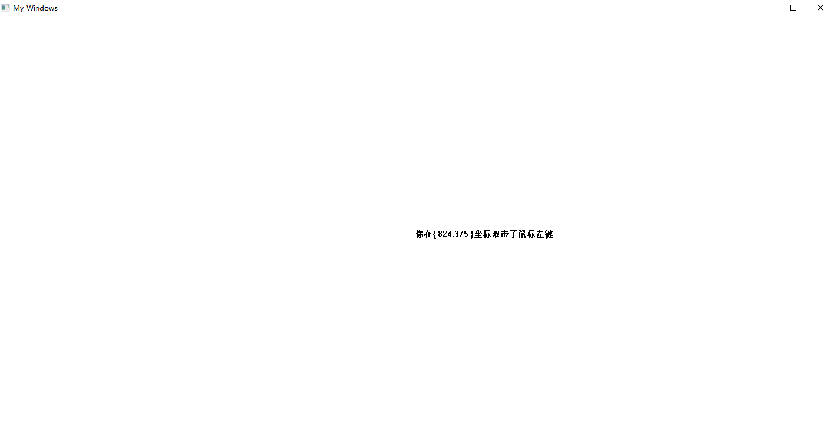
实验题目2
按住CTRL键，点击鼠标左键并移动鼠标时，实时画圆；
按住SHIFT时，点击鼠标左键并移动鼠标时，实时矩形；

实验过程2（思路（文字描述）、关键代码（WndProc 函数））
LRESULT CALLBACK WndProc(HWND hWnd,UINT message,WPARAM wParam,LPARAM lParam)
{
HDC hDC; //定义设备环境句柄.
HBRUSH hBr;
HPEN hPen;
PAINTSTRUCT ps; //定义包含绘图信息的结构体变量
static int i=0;
static int flag=0;

WORD x, y;
static char pos[20] = "";
static bool bCircle=0, bRect=0;
static RECT rect1;
RECT rect;
GetClientRect(hWnd , &rect) ;
x = LOWORD(lParam);
y = HIWORD(lParam);
switch(message)
{
case WM_CREATE:

break;

case WM_MOUSEMOVE:
rect1.right = x;
rect1.bottom = y;
if(bRect == TRUE || bCircle == TRUE){
InvalidateRect(hWnd,NULL,1);
}
break;

case WM_LBUTTONDOWN:
if(wParam&MK_CONTROL){
bCircle = 1;
bRect = 0;
rect1.left = x;
rect1.top = y;
}
else if(wParam&MK_SHIFT){
bCircle = 0;
bRect = 1;
rect1.left = x;
rect1.top = y;
}
else{
bRect = 0;
bCircle = 0;
}
break;

case WM_PAINT: //处理绘图消息.
hDC = BeginPaint(hWnd,&ps);
if(bRect == TRUE){
Ellipse(hDC, rect1.left, rect1.top, rect1.right, rect1.bottom);
}
else if(bCircle == TRUE){
Rectangle(hDC, rect1.left, rect1.top, rect1.right, rect1.bottom);
}
EndPaint(hWnd,&ps);
break;

case WM_DESTROY:
PostQuitMessage(0);
return 0;
default:
return DefWindowProc(hWnd,message,wParam,lParam);
}
return 0;
}
实验结果2:
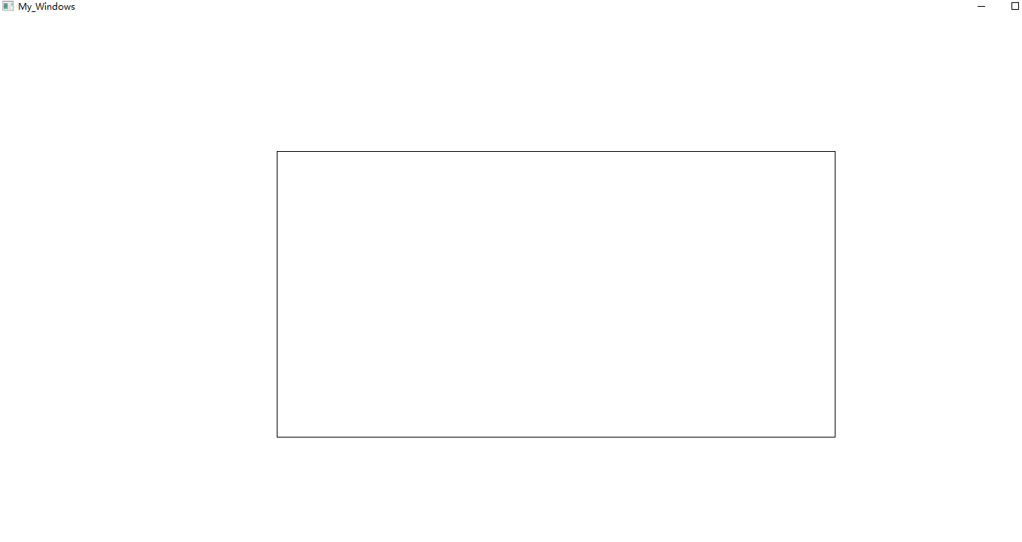

实验题目3
按住鼠标左键并在屏幕中拖动，将第一个坐标点与后面各个坐标点用黑线相连
实验过程3（思路（文字描述）、关键代码（WndProc 函数））
LRESULT CALLBACK WndProc(HWND hWnd, UINT message, WPARAM wParam, LPARAM lParam)
{
WORD x, y;
HDC hDC;
HCURSOR hCursor;
HFONT hF;
PAINTSTRUCT ps;
TEXTMETRIC tm;
RECT rect;
SIZE size;
static bool lbu = false;
static POINTS point[maxn];
static int count;

switch (message)
{
case WM_LBUTTONDOWN:
lbu = true;
count = 0;
InvalidateRect(hWnd, NULL, true);
break;
case WM_LBUTTONUP:
lbu = false;
InvalidateRect(hWnd, NULL, false);
break;
case WM_MOUSEMOVE:
if (lbu == true && count < 1000)
{
x = LOWORD(lParam);
y = HIWORD(lParam);
point[count].x = x;
point[count++].y = y;
hDC = GetDC(hWnd);
SetPixel(hDC, x, y, 0L);
ReleaseDC(hWnd, hDC);
}
break;
case WM_PAINT:
hDC = BeginPaint(hWnd, &ps);
for (int i = 0; i < count - 1; i++)
{
MoveToEx(hDC, point[0].x, point[0].y, NULL);
LineTo(hDC, point[i].x, point[i].y);
}

EndPaint(hWnd, &ps);
return 0;
break;
case WM_DESTROY:
PostQuitMessage(0);
break;
default:
return DefWindowProc(hWnd, message, wParam, lParam);
}

}
实验结果3
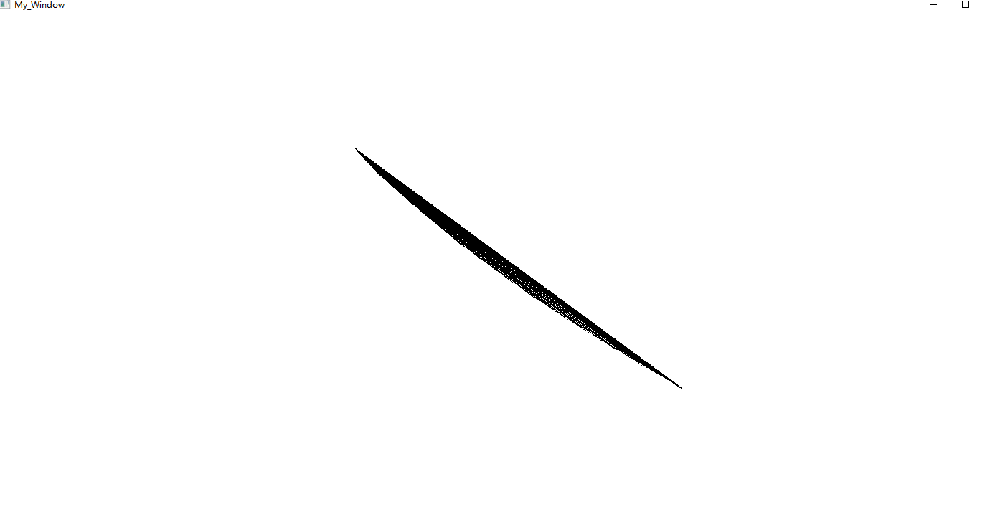

实验题目4
点击小球。
红色小球在窗体中移动，当用户点击到它之后，改成蓝色；再点后改成绿色；再点后又改成红色，依次循环。没点中时，小球变黑。小球的方向、大小、速度可固定：方向45度，球别太小，速度不要太快即可。

实验过程4（思路（文字描述）、关键代码（WndProc 函数））
LRESULT CALLBACK WndProc(HWND hWnd,UINT message,WPARAM wParam,LPARAM lParam)
{
HDC hDC; //定义设备环境句柄.
HBRUSH hBr;
HPEN hPen;
PAINTSTRUCT ps; //定义包含绘图信息的结构体变量
static int i;
static int flag=0;
WORD x, y;
static int circle_x, circle_y;
static int nCount;
int r = 40;
static POINT lp_arr[100];
int dist=0;
RECT rect;
GetClientRect(hWnd , &rect) ;
x = LOWORD(lParam);
y = HIWORD(lParam);

for(int j=0;j<100;j++) //生成正弦曲线的点坐标.
{
lp_arr[j].x=(long)(rect.left+j*20);
lp_arr[j].y=(long)(rect.bottom-j*20);
}

switch(message)
{
case WM_CREATE:
srand(time(NULL));
SetTimer(hWnd,1,500,NULL);
break;

case WM_TIMER: //处理由计时器发出的消息.
i++;
InvalidateRect(hWnd,NULL,1); //刷新用户区.
break;

case WM_LBUTTONDOWN:
dist = pow((x-lp_arr[i].x),2) + pow((y-lp_arr[i].y),2);
if(dist < r*r){
if(flag == 2){
flag = 0;
}
else
flag++;
InvalidateRect(hWnd,NULL,1);
}

break;

case WM_MOUSEMOVE:

break;

case WM_PAINT: //处理绘图消息.
hDC = BeginPaint(hWnd,&ps);
if(flag == 0){
hPen = CreatePen(PS_SOLID, 1, RGB(255,0,0));
hBr = CreateSolidBrush(RGB(255,0,0));
SelectObject(hDC, hPen);
SelectObject(hDC, hBr);
circle_x = lp_arr[i].x;
circle_y = lp_arr[i].y;
Ellipse(hDC, circle_x-r, circle_y-r, circle_x+r, circle_y+r);
DeleteObject(hPen);
DeleteObject(hBr);
}
else if(flag == 1){
hPen = CreatePen(PS_SOLID, 1, RGB(0,0,255));
hBr = CreateSolidBrush(RGB(0,0,255));
SelectObject(hDC, hPen);
SelectObject(hDC, hBr);
circle_x = lp_arr[i].x;
circle_y = lp_arr[i].y;
Ellipse(hDC, circle_x-r, circle_y-r, circle_x+r, circle_y+r);

DeleteObject(hPen);
DeleteObject(hBr);
}
else if(flag == 2){
hPen = CreatePen(PS_SOLID, 1, RGB(0,255,0));
hBr = CreateSolidBrush(RGB(0,255,0));
SelectObject(hDC, hPen);
SelectObject(hDC, hBr);
circle_x = lp_arr[i].x;
circle_y = lp_arr[i].y;
Ellipse(hDC, circle_x-r, circle_y-r, circle_x+r, circle_y+r);

DeleteObject(hPen);
DeleteObject(hBr);
}
EndPaint(hWnd,&ps);
break;

case WM_DESTROY:
PostQuitMessage(0);
return 0;
default:
return DefWindowProc(hWnd,message,wParam,lParam);
}
return 0;
}
实验结果4
